Keeping the lawns in good nick
10/4/2020
0 Comments

Owing to the very dry weather, the sprinkler system has been filled and tested. (Essential maintenance is allowed under the current Government
Sprinkler #15 (far corner of lawn 2) has also been repaired. Soil had jammed the mechanism. This means all sprinklers are working. We haven't had that for a long time.
Following Russel's guidance, the programme has been set for two irrigations per night. One comes on at at 5pm (1 min corner and 2 mins sides) then the second one at 11pm (2 mins corners + 3 mins sides). This runs for slightly less time and therefore uses slightly less water than our standard program (3 mins corners and 6 mins sides).
Now the sprinkler system is operational, Russell will put down a feed in the next few days. He will also finish putting the grass back around the repaired sprinkler.
The water consumption reading showed that we had used £0.02 worth of water over this winter. Any ideas as to how we can make some savings?
Richard Peperell
0 Comments

Croquet for All C4A update
8/4/2020
0 Comments

Dear members,
This is the 5th update on our C4A - Croquet for All – project, for three more lawns and an enlarged clubhouse.
Due to Government restrictions in response to Covid-19, most of our progress is being curtailed (eg WDC permissions, grants) which under the circumstances is not surprising.
SUMMARY OF LATEST NEWS
- Start date of project delayed until we are able to progress funding and approvals.
- We have succeeded in raising £15K from six sources so far; however, there is still a long way to go.
- We have now received all the contractors' quotations; the next task is analysing them.
- We are finding that grant-making bodies are putting their processes on hold. Nonetheless, we continue to press on to make what progress we can.
- Decision on planning permission for the extra lawns was due on 23rd March, but is currently delayed due to a ‘Holding Objection’ from Sport England. We are dealing with this but it’s tricky.
- Landlord Lease – chased WDC many, many, many times but still no further forward although we have been told it’s in the pipeline for approval.
FURTHER UPDATES
We doubt there will be much to report in the coming months and so further updates will only be made when there is a significant development or important progress. If you have any questions, please contact me or any other member of the C4A Project Management Team (David Warhurst and Duncan Reeve).
​Richard Peperell
0 Comments

A 1-minute summary of the shortest ever AGM!
4/4/2020
0 Comments

- Just 33 minutes long!
- Four people physically present (but still quorate because of email and postal responses)
- 2019 AGM minutes accepted
- Chairman, Sec and Treasurer reports accepted
- New subscription rates approved after discussion
- (First three visits to be free for beginners)
- Officers remain as for 2019; thanked for their work
- Elected committee changes: Raouf Allim, Alan Clark and Gerry Halls continue; Keith Toovey stands down; Joy Biggs and Stephen Wright join. Committee thanked for their work.
- 2020 programme paused for now because of the virus outbreak
- David Gantzel looking for a successor as Club Archivist; thanked for his great work
- Keith to gauge members' opinions about the best day to hold the AGM next year
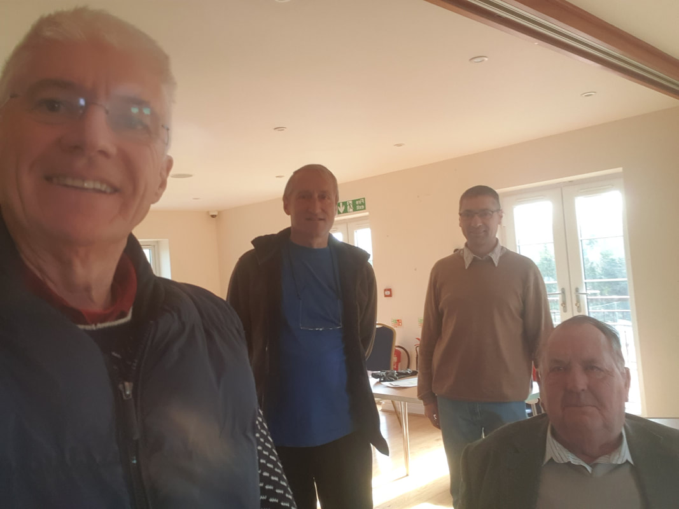
The Magnificent AGM Four: Richard, Keith P, Duncan and David
0 Comments

Membership renewals
1/4/2020
0 Comments

Following our membership renewal email a week ago, we’ve had 31 members renew as Full Members - that is the fastest in my memory as membership secretary, says Gerry Halls.
​Even without play taking place, we still have bills to pay eg landlord, water (for irrigation) and the biggest, lawn maintenance. If we are to have decent quality lawns by the time we are allowed to resume play, Russell has to do basic maintenance now, ie no less than 2 cuts per week in the summer - he says if we were to cut just once per week, then over time, the quality of the grass would suffer.
If you haven’t renewed yet, please renew your membership for the coming season.
Thank you, and best wishes,
Richard, Duncan, Gerry and Keith
0 Comments

Good news for stay at home croquet players
1/4/2020
0 Comments

If like me you are really missing your croquet, here's something to cheer you up a bit. Not the same as getting out on the lawns, but a fair second best.
It's an app called 4/20. Downloadable from all the usual sources, (Google Play, Apple store etc), the app enables you to video yourself taking a few demonstration swings (between 4 and 20, hence the name). You don't need to hit a ball, apparently, just show how you use the mallet. From that, a clever AI system works out not only some coaching points to offer you, but also calculates your % chances of success for a stroke (drive or tap, you get to choose) and even suggest what your handicap should be for AC or GC. (Sorry, Ian, that this may lead to technological redundancy for handicappers, but there are some clubs that lack one so maybe it's not all bad news.)
I've not tried it yet, but will definitely do so before 12.00 today...
​Chris Webbley
0 Comments

One to lift your spirits when you can't lift your mallet
29/3/2020
1 Comment

Cheer up, croquet players.
You know what they say.
Some games you play are bad,
They can really make you mad.
Other matches make you swear and curse.
When you're chewing croquet’s gristle,
Don't grumble, quietly whistle!
And don’t forget to hum this little verse
And,
(Sings)
Always stay on the right side of the hoop.
Always follow through, but not with a scoop,
If play seems jolly rotten,
There's something you've forgotten!
And that's to stalk and remedy your swing,
When you're missing all your jumps,
Don't be silly chumps,
Just purse your lips and whistle -- that's the thing!
And,
Always stay on the flat bit of the lawn,
(Come on!)
Make your opponent wish they’d never been born.
For croquet’s quite absurd,
If a penalty’s incurred.
You must never lose your cool and have a row,
Forget about your sin -- give the coaching staff a grin,
Enjoy it: you may muddle through somehow!
So,
Always look for a bright end to the match,
Don’t forget to play “with reasonable despatch”.
Croquet’s solid gold,
Played by young and old
Men and women equally adept,
And so it’s up to you,
Just swing your mallet true.
And if you’re wired, they’ll never intercept!
And,
Always stay on the right side of the hoop
If you fall behind, just pause and regroup.
(Come on everyone, cheer up!)
Always stay on the right side of the hoop
(Worse things happen at the 13th hoop, you know)
Always stay on the right side of the hoop
(Even Tobi Savage misses sitters sometimes)
Always stay on the right side of the hoop
(Perhaps the referee won’t see the divot you just dug)
Always stay on the right side of the hoop
(One day this will all be over and we can play again)
Always stay on the right side of the hoop
(Music fades out)
Chris Webbley, with grateful acknowledgement to Eric Idle and Monty Python's, 'Life of Brian'
​
1 Comment

HWCC closed for the time being
25/3/2020
0 Comments

Following Government guidance, the Club is closed because of the coronavirus epidemic.
Webnews will continue to post items of interest, so please look in here from time to time. It's some of the best fun you can have without venturing out of doors...
Stay safe.
Chris Webbley
0 Comments

Coronavirus guidance at 17 March 2020
18/3/2020
0 Comments

In a recent email, I attempted to address some members' concerns without offering advice other than to adhere to Government advice. If you didn't see it, here it is again.
The list below is based on the Government’s “Social Distancing” advice, as at 17 March -- please remember that advice can change.
- Avoid all unnecessary travel
- Everyone should stop non-essential contact with others particularly those aged over 70 and anyone with an underlying health condition
- Avoid pubs, clubs and theatres
This is not a summary of the Government's advice nor is it meant to be a list of the most important items. It is merely a list of what I see as relevant to HWCC. There may well be others. Many members will no doubt have different views.
It is interesting to note that the venues in last item above appear to be all indoor whereas our club activity is mostly outdoors. Risk naturally increases as we enter indoors, eg inside the clubhouse, equipment store and loo.
The government also warns of loneliness issues associated with implementing the above Social Distancing measures. This may or may not affect your decision to attend HWCC. For people under 70 and who do not have any underlying health conditions, the decision to attend HWCC may be different.
At yesterdays GC Roll-Up many members suggested measures which they thought should be implemented. These have been actioned as follows:
- No shaking hands.
- Keep a minimum 2 metres (6 feet) apart even when outside (Government recommendation). Remember that it may be easy to forget this when, for example, gathering for the start of a game, consulting a partner or looking at a close-to-the-hoop situation.
- All hand and tea towels have been removed.
- A temporary wooden barrier (see attached photos) has been installed that may be lowered when you enter the clubhouse and equipment store to prevent a second person entering that indoor space. The barrier need only be lowered by those who think it is necessary but if it is lowered please respect the views of the person inside.
- Bring your own drinking cup/mug.
At this stage, HWCC is ‘open’.
The overriding and only advice is to follow government recommendations and reach your own conclusions.
Richard Peperell
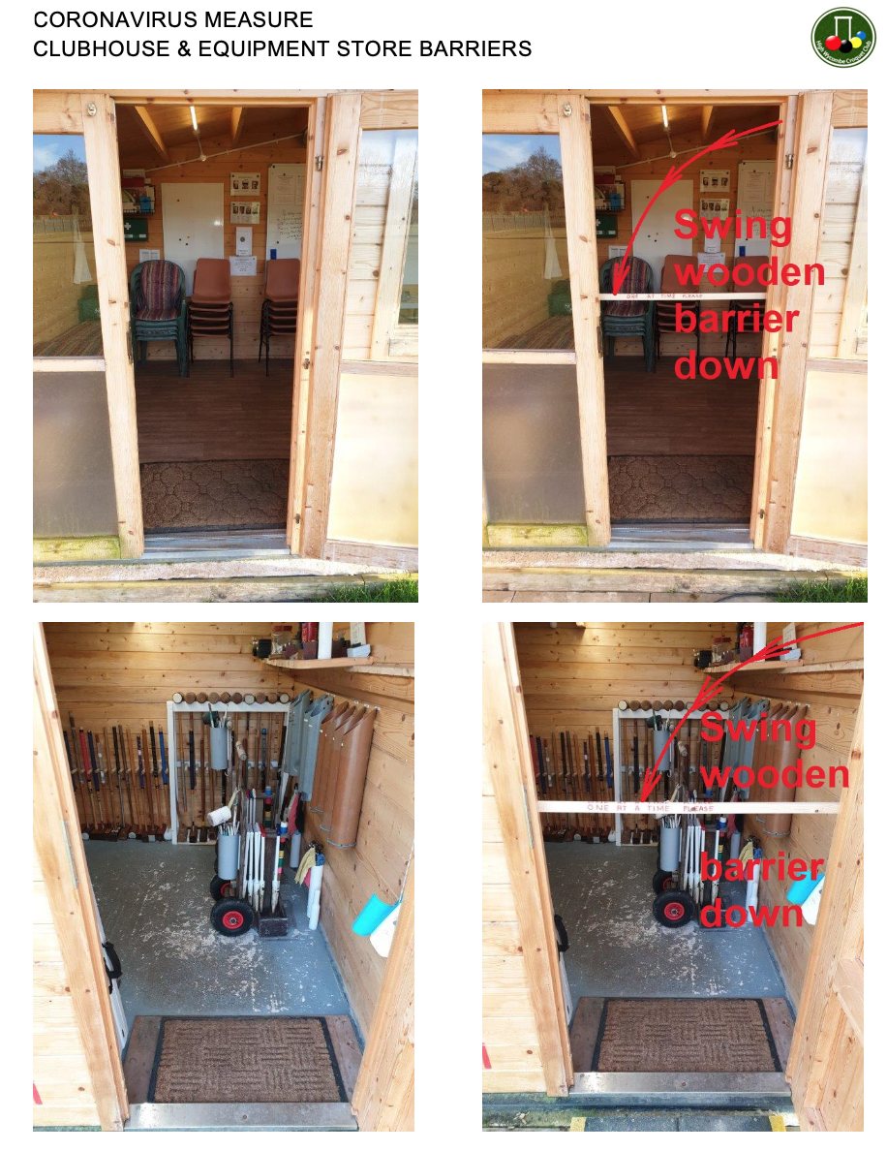
0 Comments

Teamwork gets its due reward
11/3/2020
0 Comments

I am pleased to report that we have now returned to full size lawns. Many thanks to our enthusiastic volunteers. Ian Shore, Geoff Brooks, John Maguire, Don Rutherford and Sharon Clarke meticulously measured the lawns and hoop locations to a tolerance of a few inches. David Warhurst, Keith Toovey and Raouf Allim marked out the lines. Jane Gloster and Margaret Walkely kindly laid on tea and cake. Keith and Raouf then banged in all the hoops and Ralph Baker jumped up and down on a board.
After that we all enjoyed playing on our lovely big courts in glorious sunshine.
Please note that we are continuing playing with the lawns the opposite way around for the moment (4th corners on the clubhouse side).
Thanks go to everyone for making it a cheerful and productive morning, with a lot of good-natured banter.
Raouf Allim, Lawn Manager
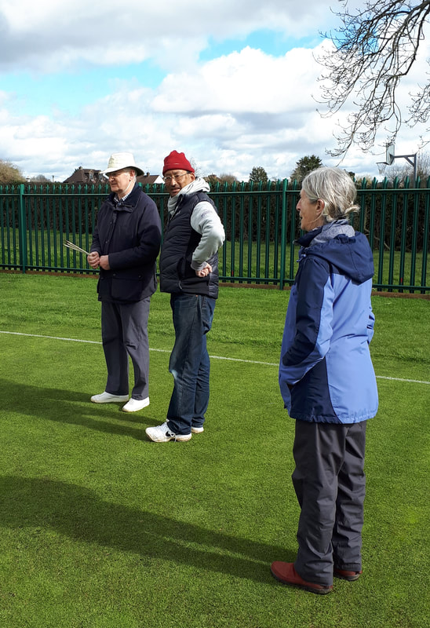
Ian wonders whether to switch to darts; Raouf wonders whether to charge for having his photo taken; and Jane wonders who's coming in for tea
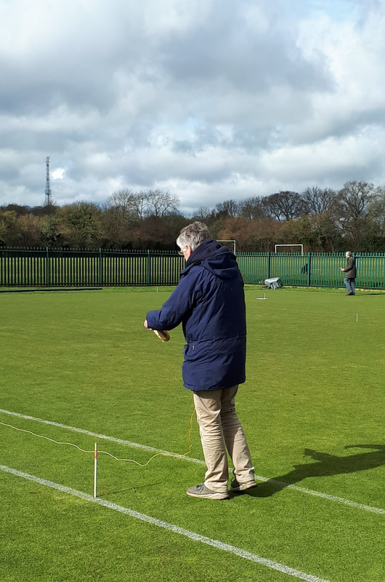
Keith measures how high his jump shots will be when they are allowed again
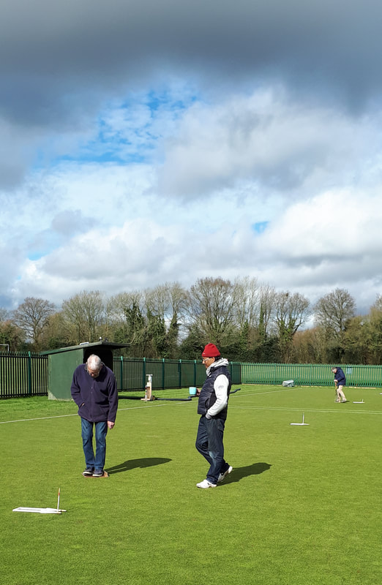
Ralph practises standing on a board; Raouf practises walking backwards holding a mug; and Keith (far distance) practises digging for gold.
0 Comments

Croquet Widow (or maybe not)
11/3/2020
1 Comment

My husband has a hobby, if that’s what you would call
A simple game of croquet, of mallet hitting ball
A gentle, easy pastime; well, gentle it is not!
Six hoops to nil is not enough, he wants to win the lot.
He’s so enthusiastic
This game is quite fantastic
With energy bombastic
He’ll give that ball a mighty swat!!
And I’ll keep washing the whites, my love,
And I’ll keep washing the whites.
And no, it is not simple, rules govern every ball
You must not play it out of turn, or crush it; that’s not all
No bevel hit or double tap, a really complex game
You must not hit the ball offside, or kick it just the same.
Rules are so magnificent
(I must not be indifferent)
All are so significant
In beating your opponent, pursuing croquet fame.
And I’ll keep washing the whites, my love,
And I’ll keep washing the whites.
Lawn croquet is played on a court, with a border
A circuit of hoops played in the right order
And you just hit the ball – oh sorry! - no, ‘strike’,
Or stun it, or roll it, and a jump shot’s all right
A game of precision
Of constant decision
With forethought and vision
Your handicap’s down in a tactical fight.
And I’ll keep washing the whites, my love,
And I’ll keep washing the whites.
As a widow of croquet, my options are few
I can become grumpy, cantankerous or blue
I can do my own thing, find a hobby that’s new
Or … learn how to play, and love the game too
An answer’s essential
Indeed consequential
For peaceful potential
‘Cos he’ll not give up croquet, whatever I do!
And I’ll keep washing the whites, my love,
And I’ll keep washing the whites.
So maybe I’ll join him, take up this strange sport
Do courses and practise, ‘til my handicap’s nought
Become a club member, pay my subs when they’re due
‘Twill not be much longer ‘til I’m showing you
With total dedication
You’ll share in my elation
A surprising presentation
The impossible has happened, I’ve won a cup too!
Then you’ll be washing my whites, my love,
Then you’ll be washing my whites!!
​Catherine Shore
1 Comment
<<Previous

Winter tournament 8 March
8/3/2020
0 Comments

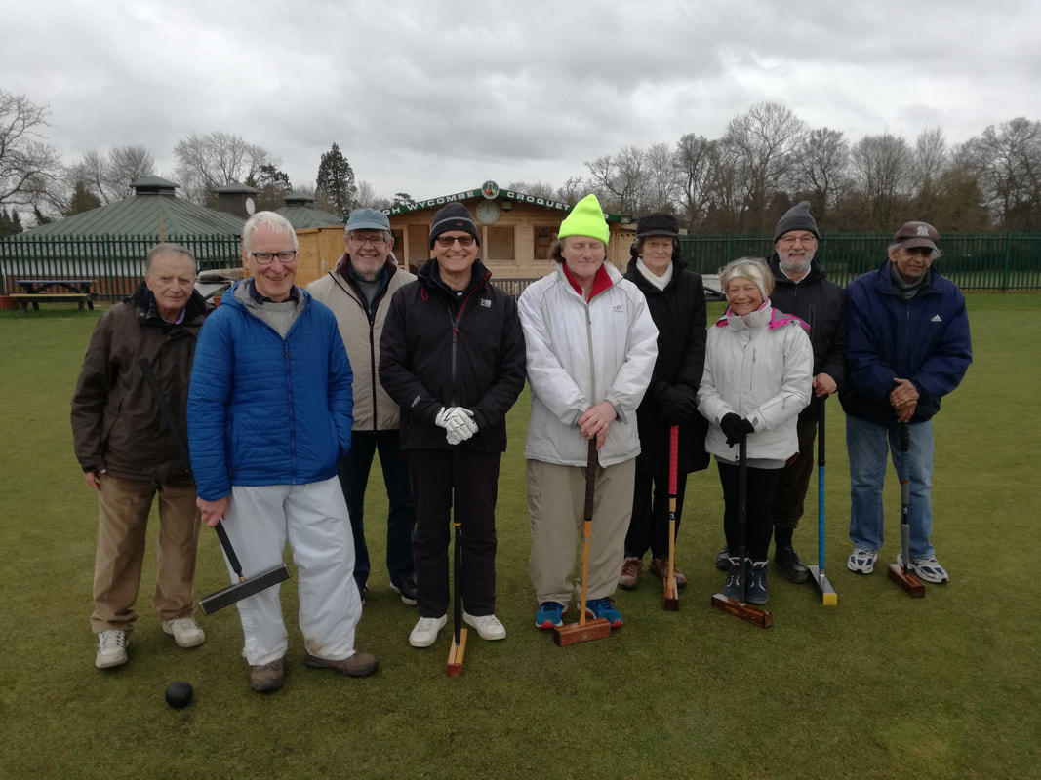
There were many reasons to enjoy the GC Handicap Winter Tournament at Hazlemere on Saturday.
- dry weather all day (though pretty chilly at times!)
- our usual excellent lawns
- a special mention to Joe Loutan, Penny Austin and Jenny Leach who were taking part in their first tournament (having received their first handicap ratings the previous day!)
- the pleasure of meeting and playing against visiting players from another Club (Ealing)
- calm and effective event management by Keith
- informal discussion of learning points from time to time during the day
- this prize to be won!
The next tournament is Saturday, 4 April. Do sign up!
​
Chris Webbley
Manager's postscript:- And the winner was the modest Mr Webbley, who played with great control throughout.

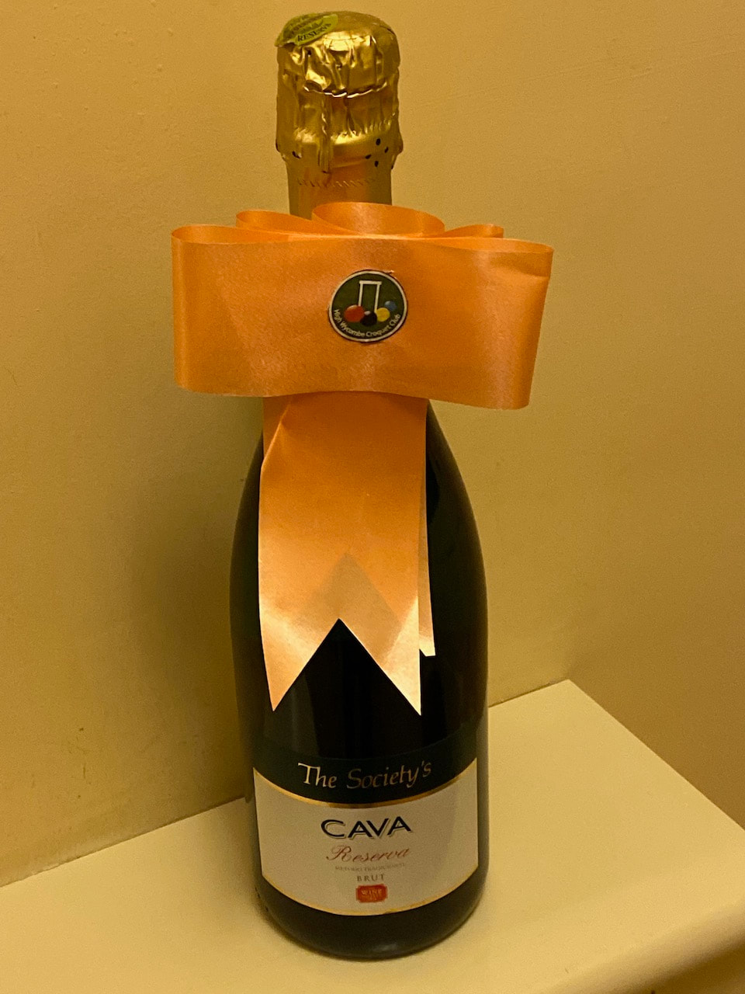
0 Comments

A first Triple Peel for Keith
8/3/2020
0 Comments

Keith Pound has completed his first Triple Peel in AC. He did it last week when playing David Warhurst in our Winter Rainbow AC Series, score 26-0 to Keith. This is no mean feat as many AC players never reach the skills required to achieve a TP. So well done Keith!
EXTRACT FROM CA WEBSITE (with some editing of names!) : TP or Triple Peel. One of the hallmarks of a good player, the triple peel allows a player to complete the game in two turns without conceding a contact. This is done by peeling the partner ball through its last 3 hoops and pegging out to win the game. TP is often seen in score lines - e.g. Pound beat Warhurst +26TP would mean that Pound won with a margin of 26 hoop/peg points, and completed a triple peel to do so.
​Richard Peperell
0 Comments

Congratulations to David
6/3/2020
0 Comments

High Wycombe now has not just one but two members in the AC International Player Development Squad for 2020! David Warhurst has been selected to take part, joining Raouf Allim.
The 2-year programme involves an Induction Day and coaching weekend in Year One, with a further coaching weekend and a mentored match in Year Two. The coaching weekends cover a variety of topics including 3-ball endings, openings, super-advanced play, POPs, lift leaves, precise play and psychology.
The mentored match weekend is an opportunity to put what has been learnt into practice against strong opposition with the benefit of guidance and feedback from experienced players.
Well done, David!
Richard Peperell
0 Comments

"Hope for the best, but it's always good to be prepared."
5/3/2020
0 Comments

A recent article in the Croquet Gazette emphasised how important it was to have had clear, easy-to-use instructions to follow when a player had a heart attack at their club. HWCC's version has now been posted up in the clubhouse (see photos).
Any actor will tell you that it pays to read the script before having to perform for real. So please take a minute when you're next at the clubhouse to think about what you would do if you were helping someone who'd been taken ill. In particular, note that you would need to call 999 twice: once to alert the emergency services and a second time when you were at the defibrillator cabinet and needed the code to unlock it.
And when you're leaving next, detour over to the pavilion to make sure you know where the defibrillator cabinet is. Without being over-dramatic, seconds can count in these situations.
Could it happen? Well, let's hope not, but best to be prepared.
Chris Webbley
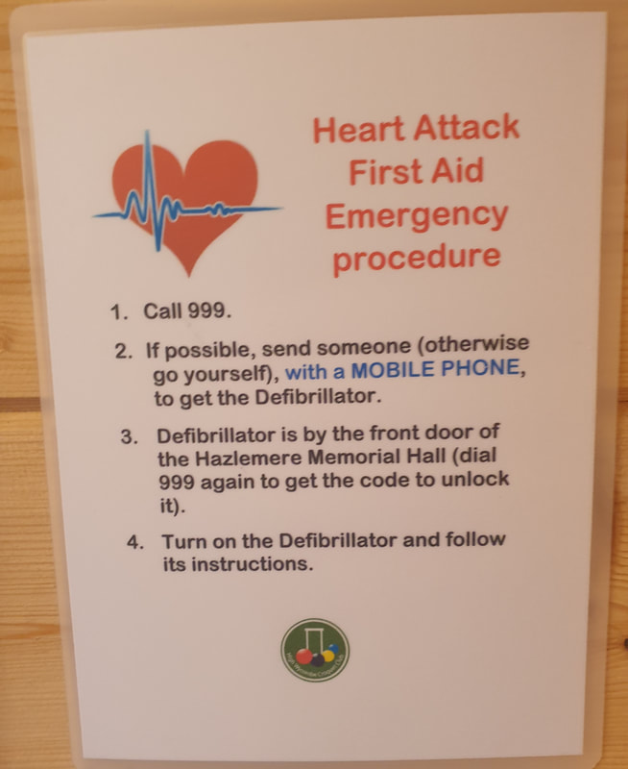
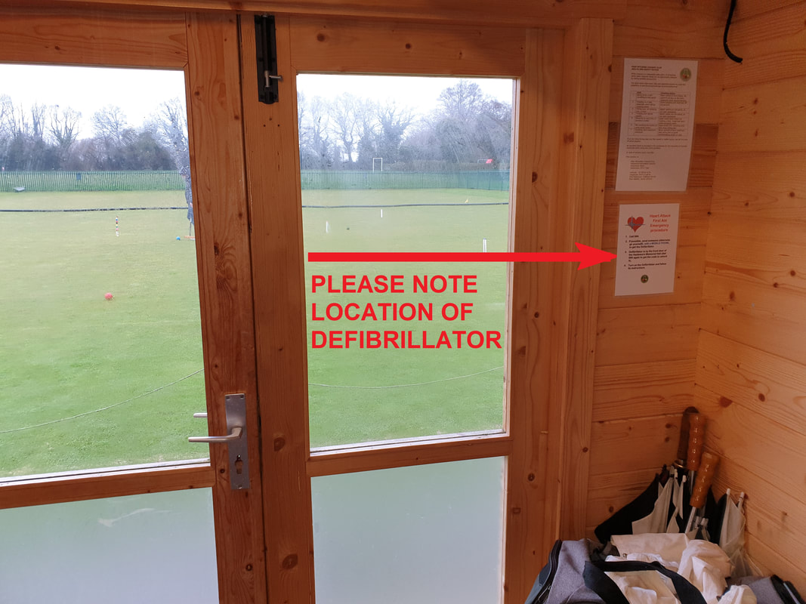
0 Comments

Congratulations to Raouf
27/2/2020
0 Comments

Congratulations to Raouf Allim on his selection for the AC International Development Squad. The catching of the Selectors' eye is a just recognition of his progress in the AC game and he will be a member of that squad for the next two years.
As members will know, Raouf is already a member of the GC International Development Squad
and is in the final year of that appointment.
Words from Phyllis Court News, courtesy of Richard Peperell
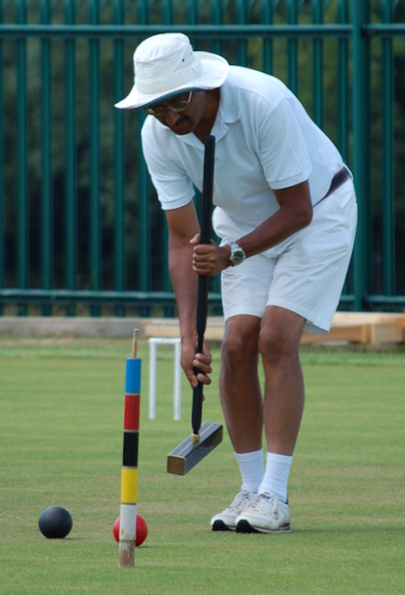
0 Comments

Top coach!
27/2/2020
0 Comments

The CA Coaching Committee is delighted to announce that, after much consideration and debate, the Coach of the Year for 2019 is Ian Shore of High Wycombe CC.
Many congratulations to Ian and thanks to him for all his work which is much appreciated. there will be an article and further information in the next CA Gazette.
​Sarah Hayes, Chair of CA Coaching Committee
0 Comments

GC Federation Shield -- HWCC through to the Quarter Finals
27/2/2020
0 Comments

High Wycombe will start to defend the Shield in a match against Crake Valley, sometime before 20 July. This is actually a Quarter-Final round, HWCC not having to compete in Round 1.
Richard Peperell
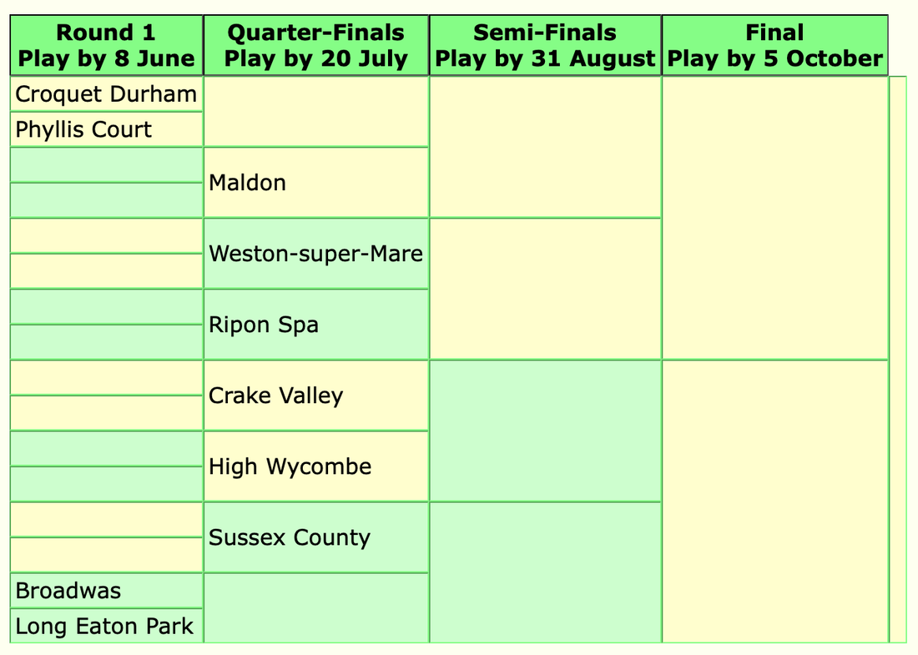
0 Comments

Meanwhile, in warmer conditions...
27/2/2020
0 Comments

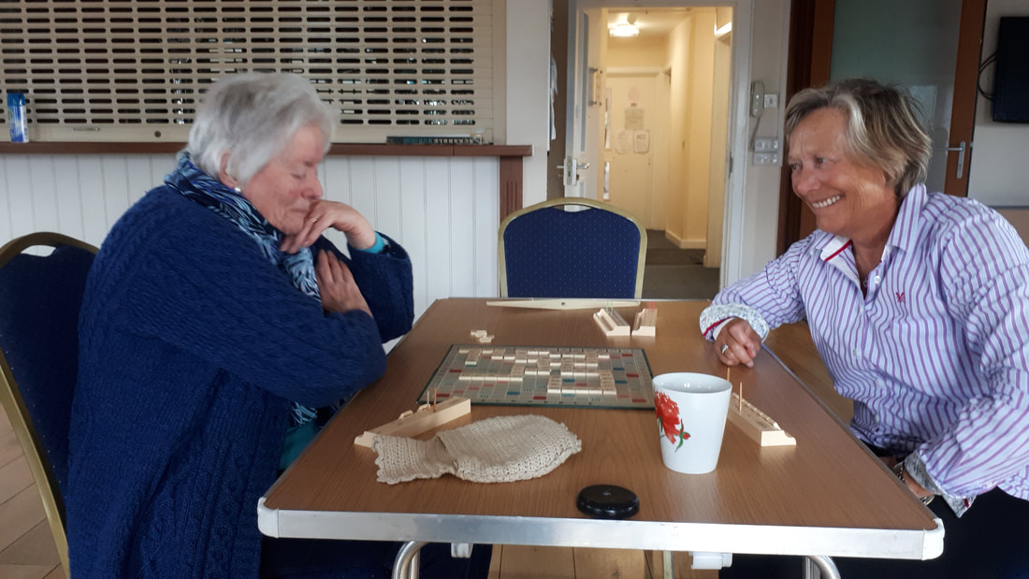
Looks as though Jenny has just got a 50-point bonus word!
0 Comments

Rabbie Burns had a few words for it!
27/2/2020
0 Comments

"Cauld blaws the wind frae east to wast,
The drift is driving sairly;
Sae loud and shrill's I hear the blast,
I'm sure it's winter fairly."
But does such weather deter croquet players? Not one whit!
Photo by Ralph Baker
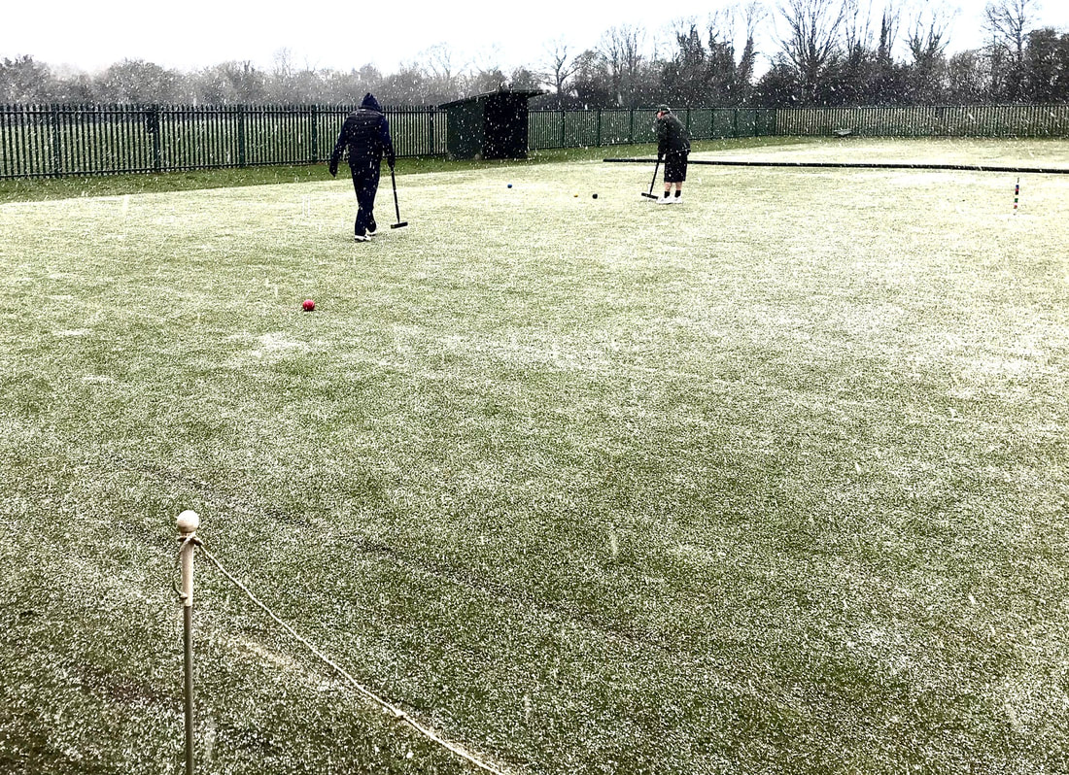
0 Comments

Our clubhouse lock has got somewhere for its friend to hang out with it...
26/2/2020
1 Comment

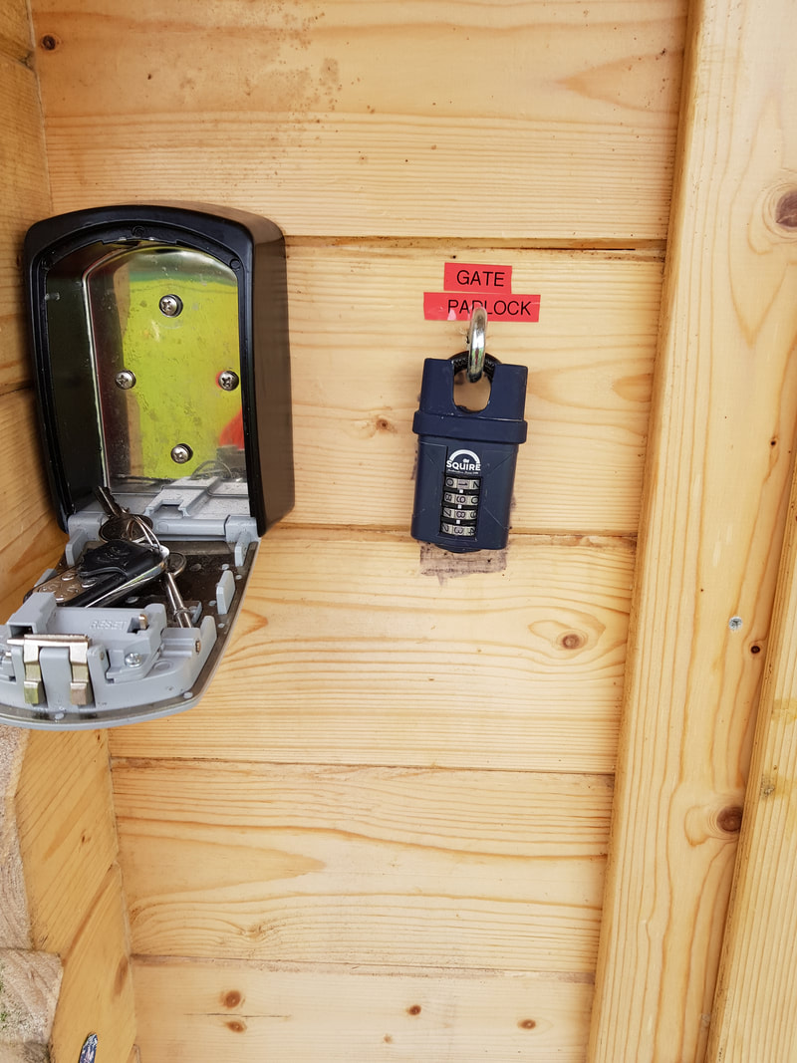
Can you imagine what they talk about?
1 Comment
<<Previous
Forward>>

